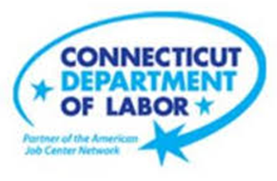

**NEW WEEKLY JOB POSTINGS FROM   
HELP WANTED ONLINE  
Office of Research**

**Week Ending April 16th, 2022: Statewide New Job Ads Fall 21% Over The Week**WETHERSFIELD, April 22nd, 2022 – During the week ending April 16th, 2022, there were 6,723 new postings, down 1,775 new ads or -21% over the week. This new ad drop is the third largest of 2022, the two larger declines occurred during the weeks ending February 19th and March 12th. Those two weeks both were adjacent to weeks with gains of 1,400 or more. This most recent over the week decline wasn’t the result of shifts within Health Care & Social Assistance, the industry with the most job ads. That industry was down 18 new ads or -1%. The three largest industry declines were Finance & Insurance, Retail Trade, and Educational Services. The largest over the week employer declines in those industries were Capital One (-195 new ads), Tutored By Teachers (-100 new ads), and Walmart/Sam’s (-42). At the national level, weekly new ads were down 15%. All but three U.S. states had over the week declines, the adjacent states of New York, Massachusetts, and Rhode Island fell by -4%, -11%, and -16% respectively.

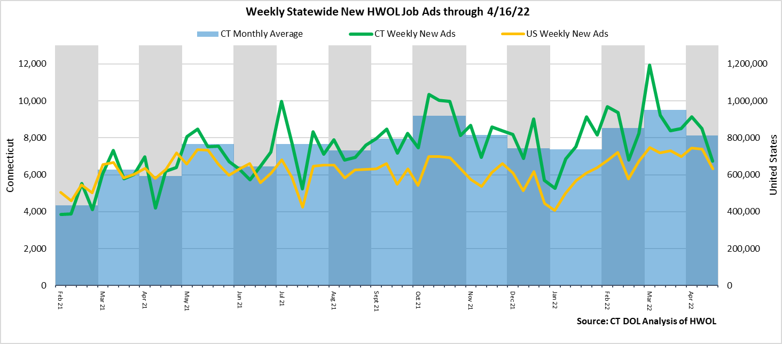  
**Industries** with the most new postings include Health Care & Social Assistance, Finance & Insurance, and Retail Trade.

**Occupations** with the most new postings include Registered Nurses, Supervisors of Retail Sales Workers, Retail Salespersons.

**Employers** with the most new postings include Capital One, Hartford Healthcare, and Yale-New Haven Health System.

**The three industries with the most new job postings were:**

* **Health Care & Social Assistance** (1,351 new postings, -1% over the week)
* **Finance & Insurance** (857 new postings, -29% over the week)
* **Retail Trade** (573 new postings, -31% over the week)

   
 During the week ending April 16th, the total ad decline of 1,775 new ads is the net result of change within 17 decreasing and 4 increasing industries. The 17 decreasing industries fell by a combined 1,842 new ads. Half of that drop occurring in four industries, Finance & Insurance (-344 new ads), Retail Trade (-255 new ads), Educational Services (-226 new ads), and Manufacturing (-97 new ads). The four increasing industries had over the week gains of 30 new ads or less. Over four weeks, new ads were down 1,917 postings. 17 industries had decreases and 4 had increases. The largest four week decrease occurred in Health Care & Social Assistance (-554 new ads) and the largest increase occurred in Finance & Insurance (+170 new ads).   
  
 For more information on total job ads by industry for Connecticut and its labor market areas, see the monthly report available here: <https://www1.ctdol.state.ct.us/lmi/hwol.asp>

**New Job Postings by Occupation** 

**The occupations with the most new postings were:**

* Registered Nurses (301 new postings, +4% over the week)
* Supervisors of Retail Salespersons (160 new postings, -17% over the week)
* Retail Sales Workers (147 new ads, -36% over the week)

**Employers with the Most New Job Postings**

Employers with the most new job postings during the week were mostly in Finance & Insurance, Healthcare Retail Trade. The 25 employers shown above account for 21 percent of all new ads. Among the top 25 employers, 12 had over the week ad increases, two were unchanged and 11 had decreases. The largest increasing top 25 employer over the week was Hartford Healthcare (+79 new ads) and the largest decreasing employer was Capital One (-195 new ads). Over four weeks, 19 of 25 employers shown above had increases and 6 had decreases. The largest of each was Capital One (+238 new ads) and Hartford Healthcare (-346 new ads).

**What is HWOL?**The **Conference Board Help Wanted Online**® Data Series (HWOL) measures the number of new, first-time Online job postings and jobs reposted from the previous month for over 16,000 Internet job boards, corporate boards and smaller job sites that serve niche markets and smaller geographic areas. To view more HWOL data, go to: <https://www1.ctdol.state.ct.us/lmi/hwol.asp>